1. Sign up & Log in to ScrumDo

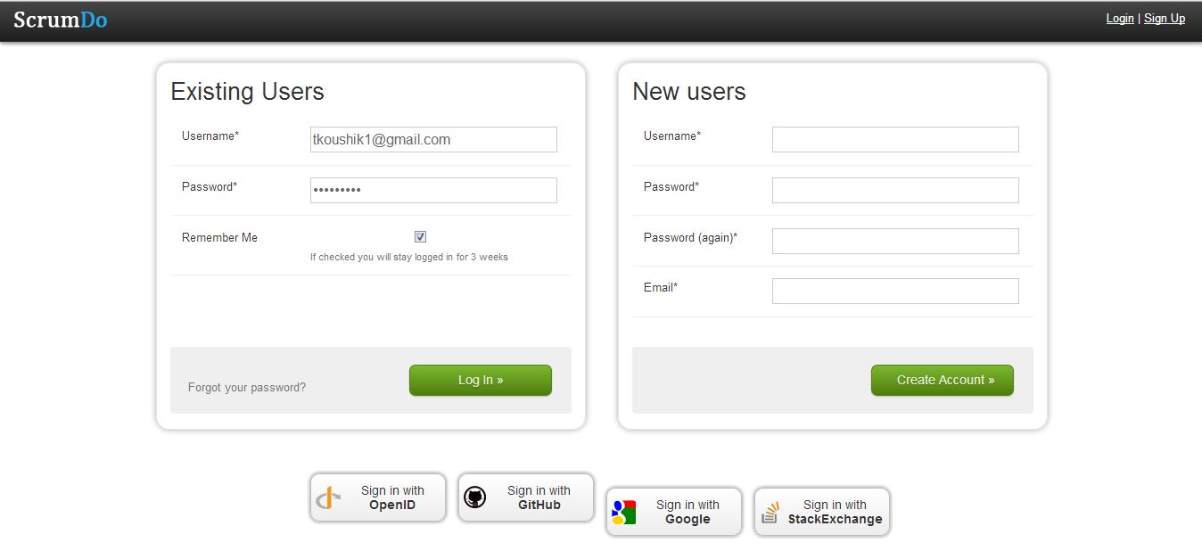

create a new organization and a new project

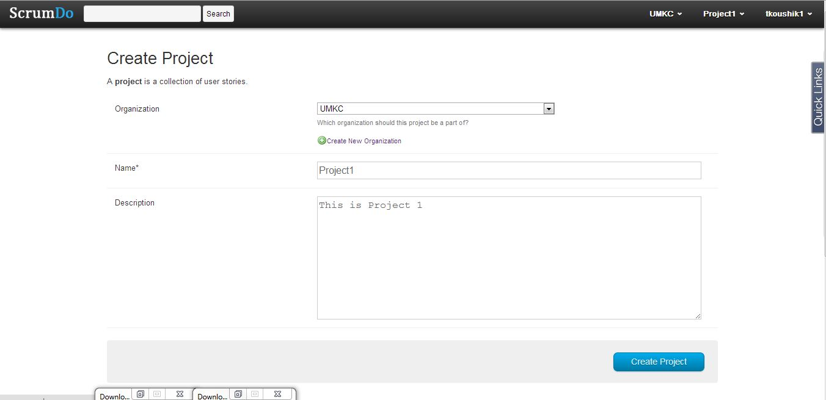

1. After creating a new organization and a new project then we create a new story (tasks) under the required project and we assign points (1 point = 8 hours) to each project and after everything entered we click on add story.

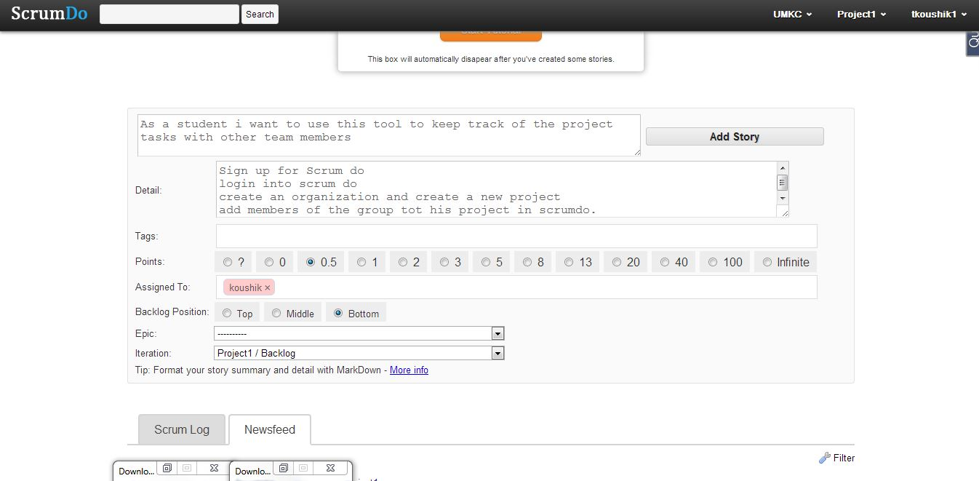

1. Here are the list of stories created under a organization and a project.

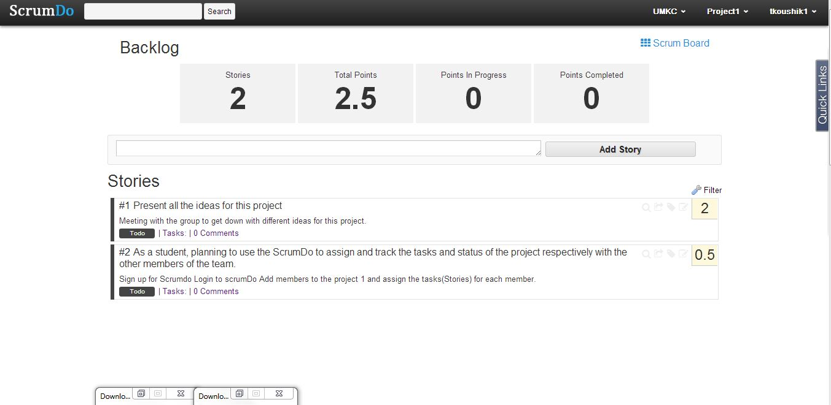

1. Then we create a iterator under the project, giving the name to the iterator and the duration range by which the iterator has to be accomplished.

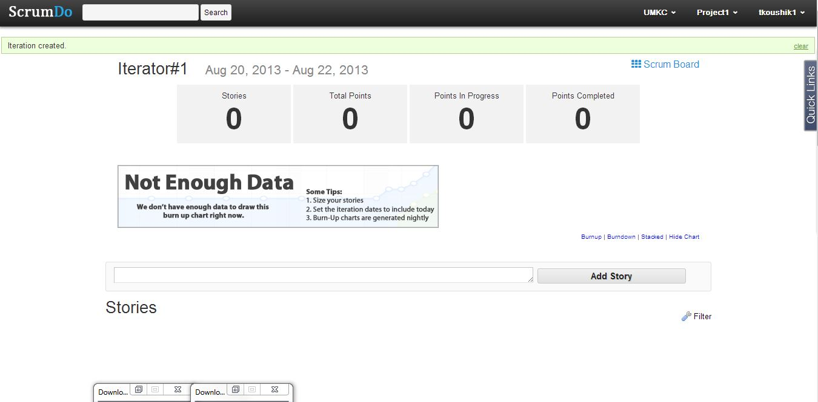

1. Here in the iterator planning we can see the list of stories that we have created and we can drag the stories to the created iterators that has to be completed in that specific duration of time.

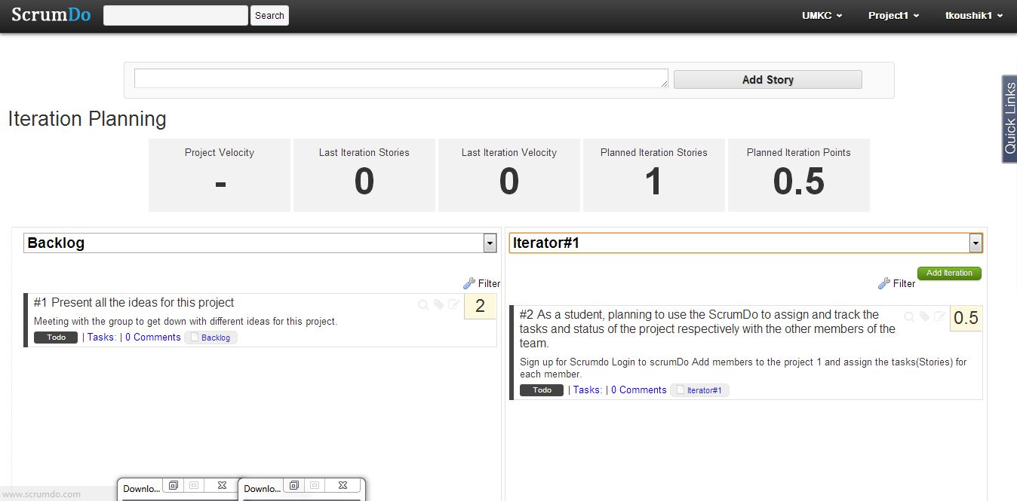

1. We can also create Epics which is kind of a long story and it can have other sub epics and new stories in it thus it’s like dividing a big task into a manageable chunks of small tasks. Here I have created an Epic Story and created 2 new stories under the Parent Epic.

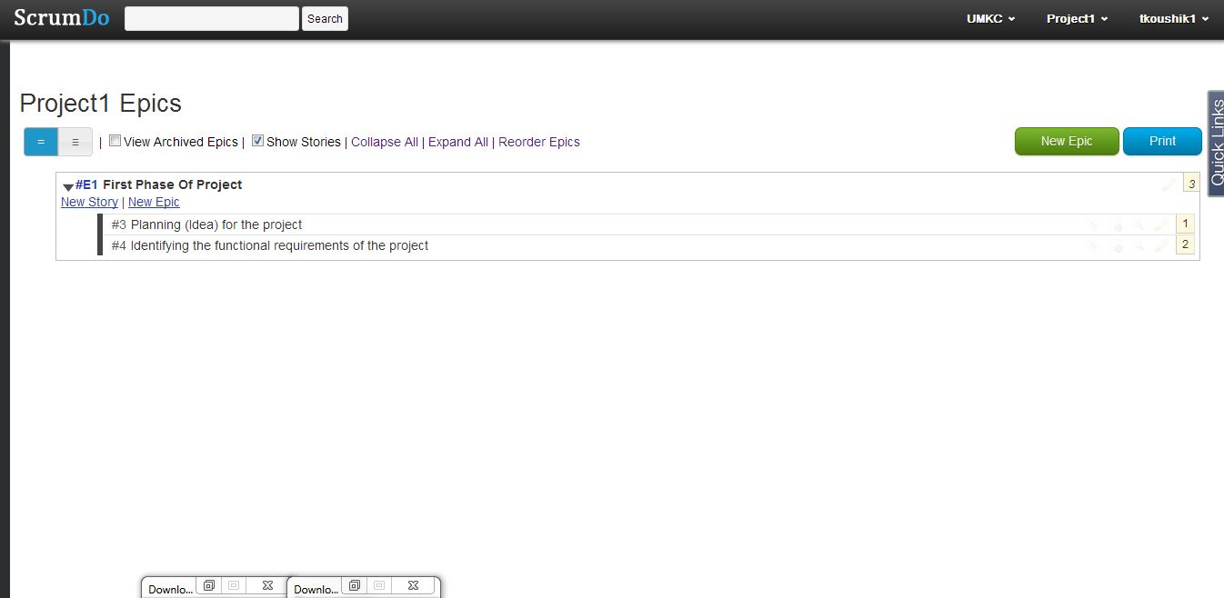

1. As we go to Scrum Board its is a portal where we have the summary of the tasks of the selected project whether the tasks are in the Todo or doing or reviewing or done. We can change the status of the tasks by selecting the tasks which will be in todo state by default by dragging it to any one of the other columns.

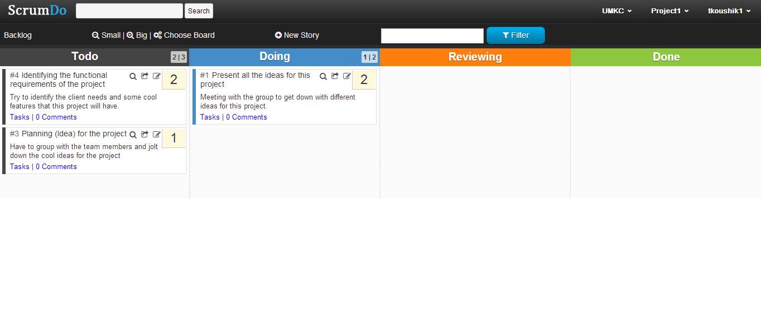

1. In the following picture there is a change in status of the task once I dragged a task from todo column to doing column.

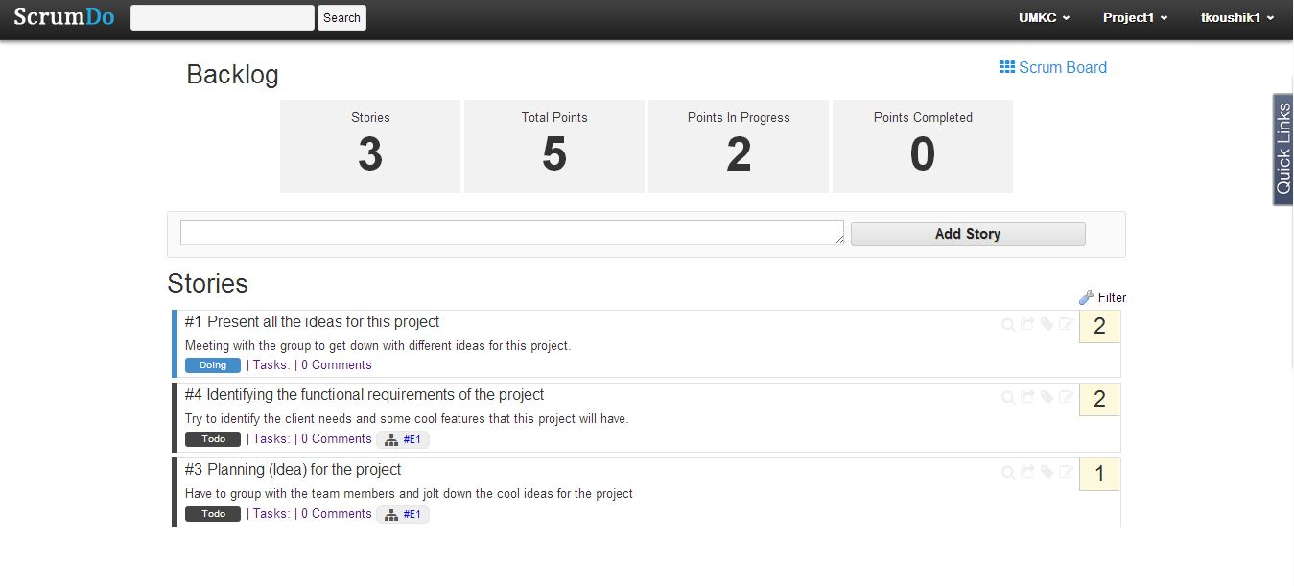

1. We can create teams under organization name as shown in the picture thus giving the name to the team and grant them the permissions.

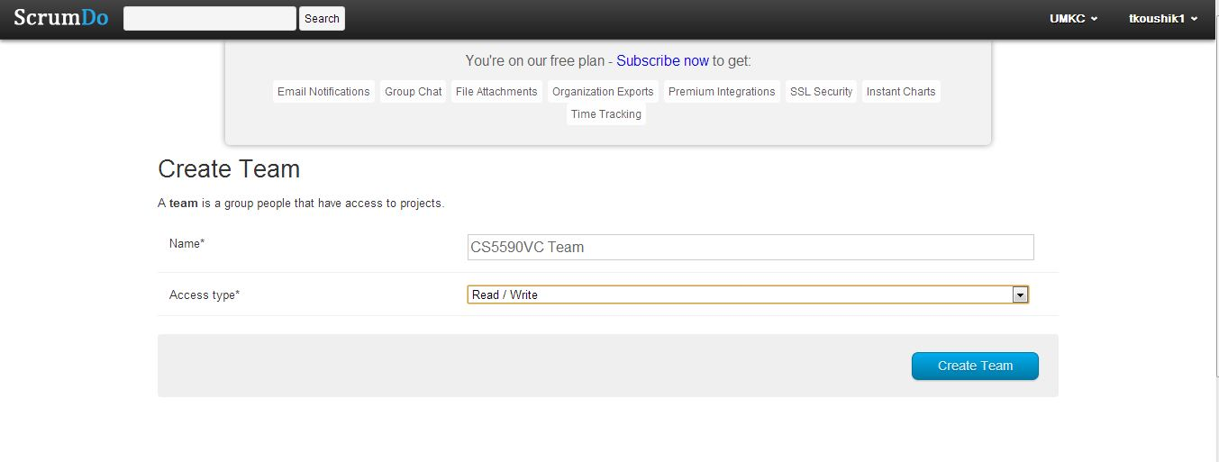

1. You can add the team members by inviting them through their Email addresses and grant them access to what projects they can work on and also you can have the option to delete the whole team or jus a member.

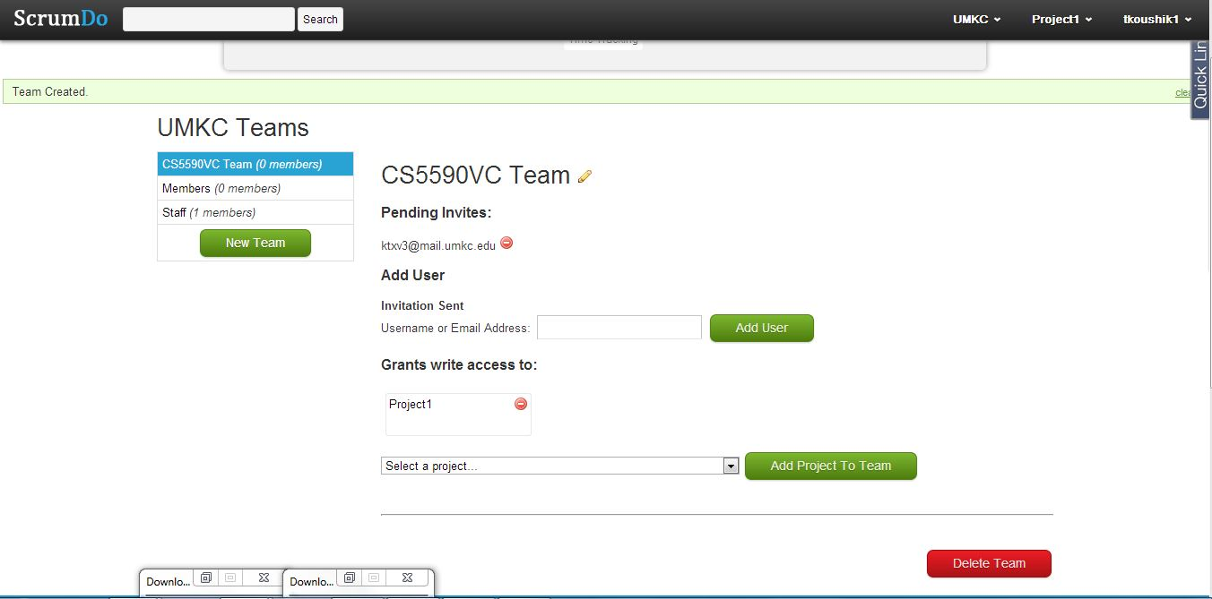

1. The invitation mail to a member of the team who is invited looks like this where he has click the hyperlink link given and accept the invitation to join the team.

